**Project Name:** E-Commerce Website  
**Developer:** Tanmay Patil

1. **INTRODUCTION**

**1.1. Project Overview**

This project is an e-commerce website developed using HTML, CSS, and JavaScript. The website allows users to browse products, add and remove them to a shopping cart, The focus of the project is to provide a user-friendly interface, implement a fully functional cart system, and simulate a complete online shopping experience.

**1.2. Purpose**

The purpose of this project is to create a simple yet functional e-commerce platform that demonstrates key web development skills, including responsive design, interactive UI elements, local storage management, and dynamic content updates using JavaScript.

1. **FEATURES**

**2.1.Home Page**

* The landing page welcomes users with a banner and a list of featured products.
* A navigation bar allows users to explore categories or return to the homepage.

**2.2. Product Listing**

* Users can browse different products in various categories.
* Each product displays an image, name, price, and an "Add to Cart" button.

**2.3. Shopping Cart**

* The cart system allows users to add, remove, items.
* Cart items and total price are stored in local storage to preserve the cart state between sessions.

1. **TECHNOLOGIES USED**

**3.1. HTML**

* Structuring the website into different pages (Home, Product Listing, Cart).
* Using semantic tags like <header>, <nav>, <section>, and <footer> for better organization and SEO.

**3.2. CSS & Bootstrap**

* Bootstrap 5 for responsive grid layouts, components like buttons, cards, forms, and modals.
* Custom styles for each section of the website, including layout and buttons.
* Responsive design to ensure compatibility with various screen sizes (mobile, tablet, desktop).
* Use of Flexbox layout management.

**3.3. JavaScript**

* DOM manipulation for dynamic content updates.
* Event handling for adding/removing products from the cart.
* Local Storage API to store cart data persistently.

1. **SCREENSHOTS**
2. **Home page**

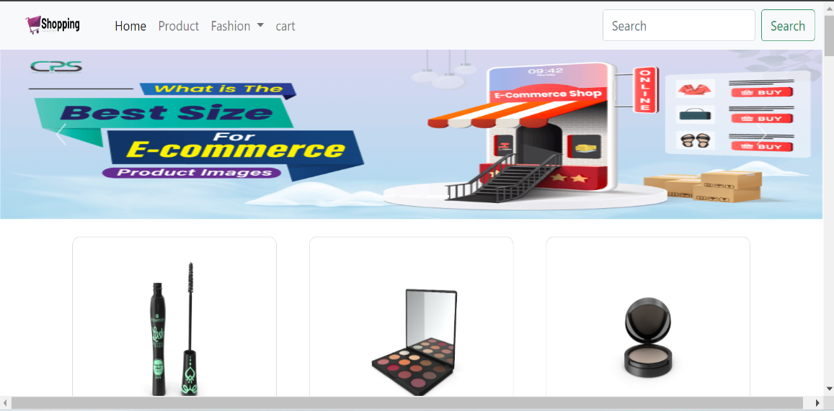

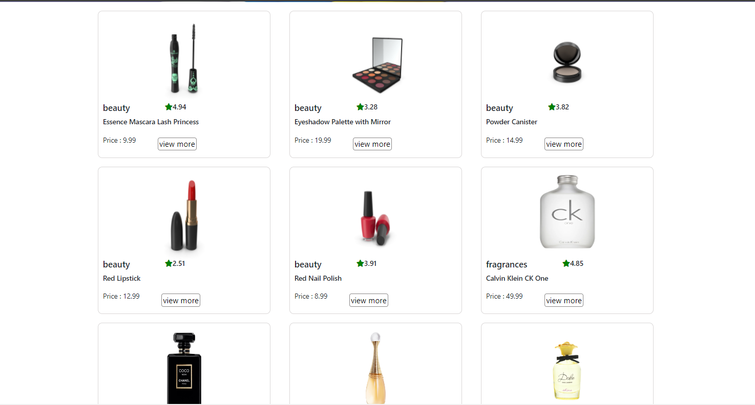

1. **Product page**

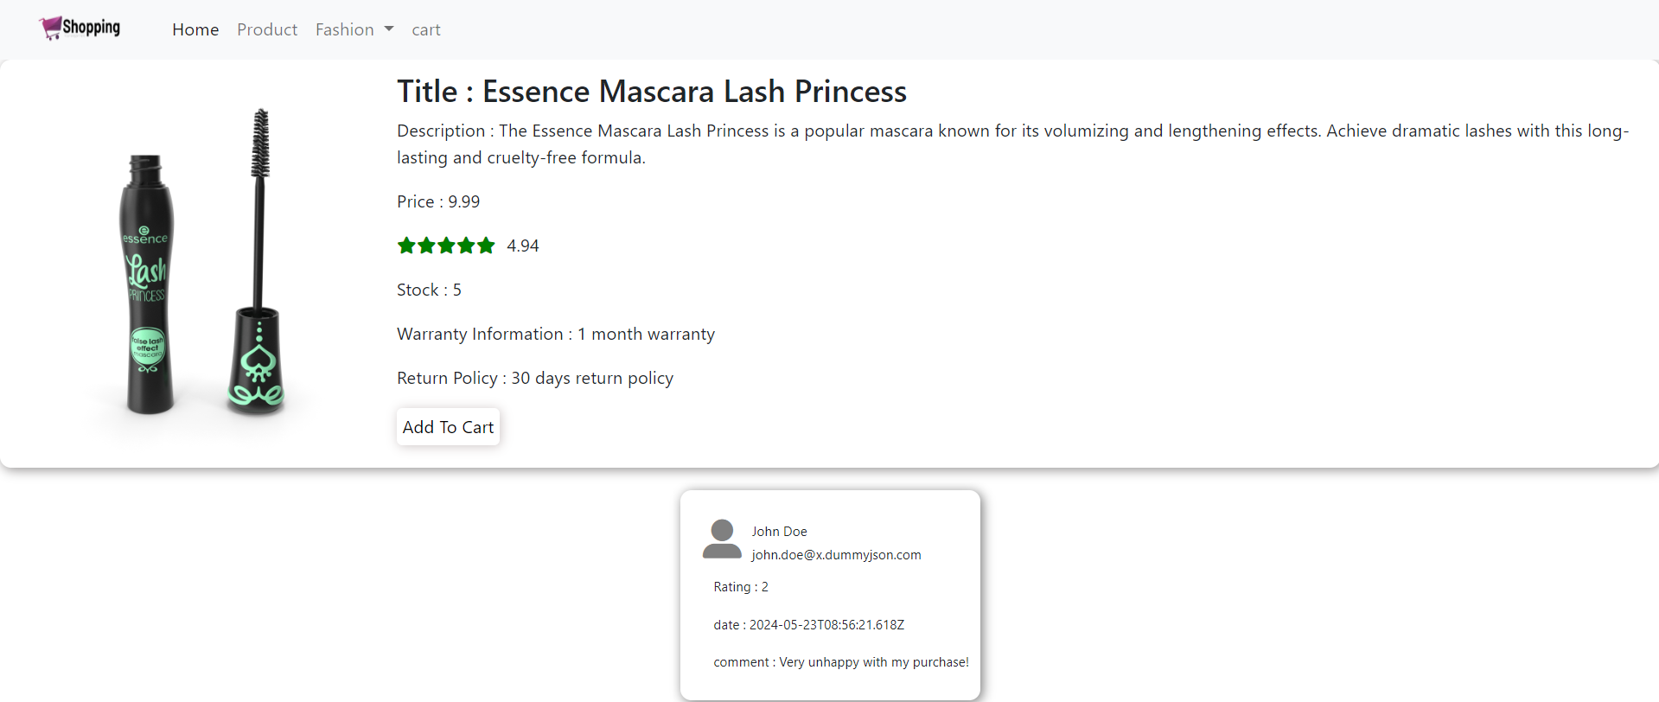

1. **Cart Page**

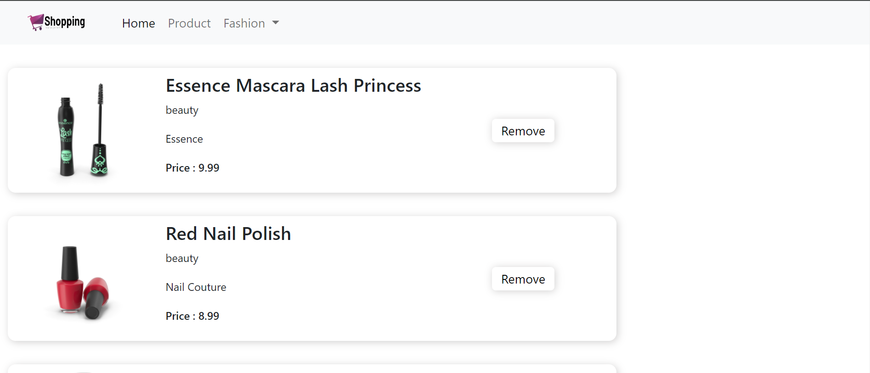

1. **CONCLUSION**

This e-commerce website provides a complete user experience with basic shopping functionality. Through the use of HTML, CSS, and JavaScript, the website is both visually appealing and highly functional. This project can be further expanded to include additional features such as user authentication, real payment processing, and login and logout features.